* **Activity 3:**

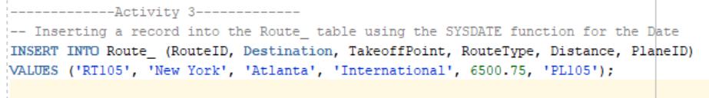Inserting Special Values

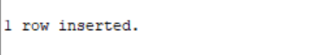OUTPUT: